BUSINESS ANALYTICS / MANAGEMENT REPORT
E-commerce
Fulfilment & Delivery
Performance Analysis
A data-led review of service reliability, customer feedback, freight economics and regional exposure.
8.11%  Late delivery rate  96,470 eligible delivered orders | 91.89%  On time / early  88,644 orders | 1.73 pts  Review score gap  4.29 vs. 2.57
PROJECT BASIS
Olist Brazilian E-Commerce Public Dataset | 9 cleaned relational tables | Python / pandas | SQLite SQL | Power BI
Purchase-date coverage: 04 Sep 2016 to 17 Oct 2018 | Prepared: 06 November 2026
Prepared from the supplied cleaned CSVs, SQL analysis script, Python notebook source, project notes and four Power BI dashboard captures.

Executive Summary
This project evaluates how delivery timing, customer geography, seller concentration and product freight economics vary across the Olist marketplace dataset. The central management signal is clear: 8.11% of eligible delivered orders arrived after the estimated date, and late orders carry materially lower average review scores than on-time/early orders.
Management takeaway
Use 8.11% as the validated late-delivery baseline, prioritise regional diagnostics where late rate and order volume overlap (especially RJ and BA), and investigate carrier / dispatch causes before claiming operational root causes or benefits.

Headline performance
KPI | Validated result | Definition / basis
Orders in source | 99,441 | Unique order_id records in orders_clean
Delivered orders | 96,478 | order_status = delivered
Eligible delivered orders | 96,470 | Delivered orders with purchase, actual-delivery and estimate timestamps
Late delivered orders | 7,826 | delay_days > 0
Late delivery rate | 8.11% | 7,826 / 96,470
On time / early | 88,644 (91.89%) | delay_days <= 0
Average delivery time | 12.56 days | Purchase timestamp to actual customer delivery
Average delay vs estimate | -11.18 days | Negative means earlier than the estimate on average
Average freight per delivered order | 22.79 | Sum of item freight per order, averaged across eligible delivered orders
Total freight / average per item | 2.252M / 19.99 | All 112,650 order-item records; dataset currency units

What management should take from this
- Most eligible delivered orders (91.89%) met or beat the estimated delivery date, but the 7,826 late orders are a material service cohort.
- Late orders averaged 2.57 out of 5 at order-level review score, compared with 4.29 for on-time/early orders; this is an association, not a causal estimate.
- State-level variation and a 71.32% seller-item concentration in São Paulo justify a targeted network diagnostic, not an automatic assumption that geography caused delays.
- Freight equals 16.57% of recorded item sales at the full item-table grain; category-level cost differences should be reviewed alongside item weight, price and order mix.
Metric caveat: the dashboard’s 4.09 overall review KPI is the mean of individual review records. The 4.16 figure in the older written summary is an equal-weighted average of order-level review means. Both can be valid at different grains; this report labels the grain each time.

1. Business Problem and Analytical Objectives

Business problem statement
Evidence-based problem statement
What factors are associated with late delivery, freight cost variation and customer review scores in an e-commerce fulfilment operation? This analysis uses historical order, item, customer, seller, payment, product, review and geolocation data to describe performance differences and identify areas that warrant operational investigation.

The project does not establish a verified cause of late delivery. Its purpose is to quantify service outcomes, identify where performance differs, and provide a defensible shortlist for process-level investigation.

Why this matters to the business
- Delivery reliability is part of the post-purchase experience; review scores differ substantially between late and on-time/early cohorts.
- Regional and seller-side concentration can make a single marketplace-wide average conceal pockets of operational exposure.
- Freight is a sizeable component of item value in aggregate; category and seller economics merit closer margin and carrier review.

Business objectives
Objective | Analytical response
Measure delivery reliability | Calculate eligible delivered orders, late orders, on-time/early rate, delivery days and delay days.
Connect service to experience | Compare review scores by delivery status and delay band, with review coverage stated.
Locate regional variation | Compare customer-state late rates with their eligible order counts and average delivery days.
Understand freight exposure | Measure total/per-item/per-order freight and compare category-level freight with item value and weight.
Assess seller concentration | Measure item and order volume by seller state to inform network investigations.
Protect analytical integrity | Validate keys, relationships, missingness and grain before building dashboard measures.

Management questions answered
- What share of eligible delivered orders arrived late, and how many orders support the rate?
- How do average delivery duration and customer review scores differ by delivery outcome?
- Which customer states show elevated late rates, and which also carry meaningful order volume?
- Which product categories have higher freight per item, and where is seller activity concentrated?

2. Dataset, Scope and Analytical Method
The supplied files contain nine cleaned relational tables from the Olist Brazilian E-Commerce Public Dataset. The observed purchase-date range is 04 September 2016 to 17 October 2018 (25 distinct purchase months).

Source tables and natural grain
Cleaned table | Rows | Analytical grain
orders_clean | 99,441 | One row per order
customers_clean | 99,441 | One row per customer_id
order_items_clean | 112,650 | One row per order_id + order_item_id
payments_clean | 103,886 | One row per order_id + payment_sequential
reviews_clean | 99,224 | Review record; multiple reviews may relate to an order
products_clean | 32,951 | One row per product_id
sellers_clean | 3,095 | One row per seller_id
geolocation_clean | 19,015 | One row per ZIP-prefix lookup after aggregation
category_translation_clean | 71 | One row per Portuguese category mapping

Workflow
Step | Work performed | Business purpose
1. Profile | Inspect table sizes, column types, missing values, duplicate rows, candidate keys and relationships. | Understand coverage and prevent invalid joins.
2. Prepare | Convert timestamps, standardise selected text fields, derive delivery_days, delay_days and late flag. | Create consistent delivery dimensions.
3. Aggregate safely | Summarise items, payments and reviews to order grain before joining to orders. | Avoid multiplying order-level records.
4. Analyse | Use Python/pandas EDA and SQLite views for delivery, review, region, category, freight and seller analyses. | Answer management questions with reproducible logic.
5. Communicate | Keep nine natural-grain tables for Power BI; build executive, delivery, freight/seller and data-quality views. | Enable stakeholder exploration without flattening incompatible grains.

Model design principle
Keep orders, order items, payments and reviews at their natural grains. The SQL script pre-aggregates one-to-many tables before constructing the one-row-per-order analysis view; category and seller analyses remain at order-item grain.

3. Data Preparation and Quality Audit
The nine supplied cleaned tables were loaded and independently profiled. The supplied SQL analysis script was also executed in SQLite after importing the CSVs under its expected table names.

Validation results
Check | Observed result | Status / interpretation
Full-row duplicates | 0 in all nine tables | Pass
Candidate keys | 0 duplicates for customer_id, order_id, product_id and seller_id | Pass
Composite keys | 0 duplicates for (order_id, order_item_id) and (order_id, payment_sequential) | Pass
Core relationships | 0 orphan orders-to-customers; 0 orphan order items-to-orders/products/sellers | Pass
Eligible delivery dates | 96,470 / 96,478 delivered orders = 99.99% | Pass; 8 delivered rows excluded from timing KPI
Product category mapping | 98.11% of product rows have a non-null translated category | Coverage; 610 missing source categories and 13 unmatched category values
Customer ZIP match | 99.72% of customer ZIP prefixes found in the aggregated geolocation lookup | Coverage; not a route-distance metric
Review order coverage | 98,673 / 99,441 orders = 99.23% have a review record | Coverage; comments may be blank

Important missingness is not all a defect
- Orders table: 2,965 rows have missing actual delivery timestamp and derived delivery fields; these are mostly non-delivered statuses. Only 8 delivered orders are missing at least one delivery KPI timestamp.
- Reviews table: review_score is complete; missing review titles (87,656) and comment messages (58,247) are optional text fields, not missing scores.
- Products table: 610 rows have a missing product category; two rows have missing physical metadata fields (weight/size columns). Product metadata gaps should be considered when interpreting freight-weight comparisons.

Power BI data-quality page: correction required
Dashboard visual audit
The supplied data-quality screenshot repeats approximately 0.57M rows for every source table. The actual row counts range from 71 category mappings to 112,650 order items; 569,774 is the sum of rows across all nine tables, not the row count of each table. The missing-value chart also repeats approximately 0.15M across tables; the actual missing cells are concentrated in orders (13,803), products (2,448) and optional review text fields (145,903). Do not use those two repeated-value visuals as per-table audit evidence until their DAX/model logic is corrected.

All four tested foreign-key relationships had zero orphan rows. That supports the tested relationships only; it is not a blanket certification of every possible model relationship or Power BI measure.

4. KPI Definitions and Reconciliation
KPI | Definition / calculation | Validated result
Eligible delivered orders | Delivered orders with purchase, actual delivery and estimated delivery timestamps. | 96,470
Late delivery rate | Late eligible delivered orders (delay_days > 0) / eligible delivered orders. | 8.11%
On-time / early rate | Eligible delivered orders with delay_days <= 0 / eligible delivered orders. | 91.89%
Delivery days | Actual customer delivery timestamp minus purchase timestamp, in days. | 12.56 avg; 10.22 median
Delay days | Actual customer delivery timestamp minus estimated delivery timestamp, in days. | -11.18 avg overall; +9.55 avg among late orders
Review score (overall) | Mean of review_score across individual review records. | 4.09 / 5
Review score (by delivery outcome) | Mean of per-order review-score average, equally weighting orders in each delivery cohort. | 4.29 on-time/early; 2.57 late
Freight per item | Mean freight_value on order_items_clean across all order items. | 19.99
Freight per delivered order | Sum item freight per order, averaged across eligible delivered orders. | 22.79
Freight as % of item sales | Sum freight_value / sum price across all order items. | 16.57%

Reconciliation of supplied narrative and dashboard values
Metric | Supplied discrepancy | Resolution used in this report
Late delivery rate | 6.77% in executive_summary.md; 8.11% in dashboard and recalculation. | Use 8.11%: 7,826 / 96,470; the 6.77% figure is stale or uses an undocumented denominator.
Average delivery days | 12.09 in executive_summary.md; 12.56 in dashboard and recalculation. | Use 12.56: timestamp difference recomputed from the delivered eligible cohort.
Average delay vs estimate | -11.88 in executive_summary.md; -11.18 in recalculation and SQL execution. | Use -11.18; the older -11.88 is not reproduced by supplied cleaned data.
Average review score | 4.09 in Power BI screenshot; 4.16 in executive_summary.md. | 4.09 = mean of raw review records; 4.16 = mean of per-order averages. Label grain; do not merge.
Total freight | 2.20M in executive_summary.md; 2.25M in Power BI screenshot. | Both reconcile: 2.198M delivered items only vs 2.252M across all order items.
Total orders | 113K labelled “Total Orders” in Executive Overview screenshot. | 113K is 112,650 order-item rows. Actual unique orders = 99,441; correct the card label/value.

Validation status: core headline delivery KPIs, review comparison, state results, category freight results and seller concentration were independently recomputed from the supplied CSVs and cross-checked against the executed SQL view. The notebook file contains 95 source cells but no saved cell outputs; the notebook was code-reviewed, not run end-to-end against the original Kaggle raw-input path.

5. Key Findings: Delivery Reliability and Customer Experience

Finding 1 — 8.11% of eligible deliveries were late
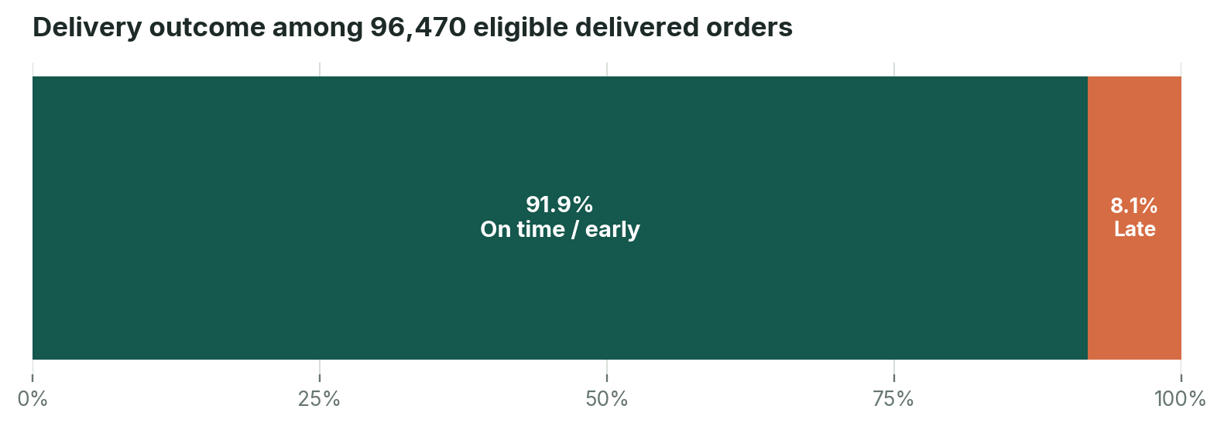
Figure 1. Delivery outcome mix; denominator = 96,470 eligible delivered orders. Source: orders_clean; recalculated from timestamps.
Of 96,470 eligible delivered orders, 7,826 arrived after the estimated delivery date. The remaining 88,644 arrived on or before the estimate. Average delivery time was 12.56 days, while average delay relative to the estimate was -11.18 days overall. The negative overall delay indicates that orders were, on average, delivered before the promise date; it does not mean late orders were early.
Late cohort behaviour
The 7,826 late orders averaged 9.55 days after the estimated date and 31.52 days from purchase to delivery. The on-time/early cohort averaged 10.88 days from purchase to delivery.

Finding 2 — Review scores are materially lower for late orders
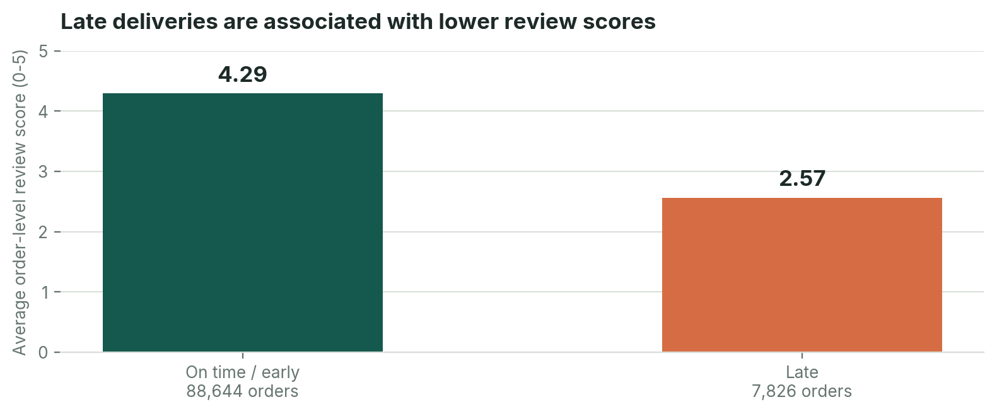
Figure 2. Mean order-level review score by delivery outcome. Orders with reviews only contribute to the mean.
The order-level mean review score is 4.29 for on-time/early orders and 2.57 for late orders, a 1.73-point gap. Review coverage is 99.33% of eligible delivered orders. The direction and size of the gap support treating delivery reliability as a customer-experience signal; they do not prove lateness is the only driver of a review.

6. Key Findings: Regional Exposure

Finding 3 — Rates need to be read with supporting volume
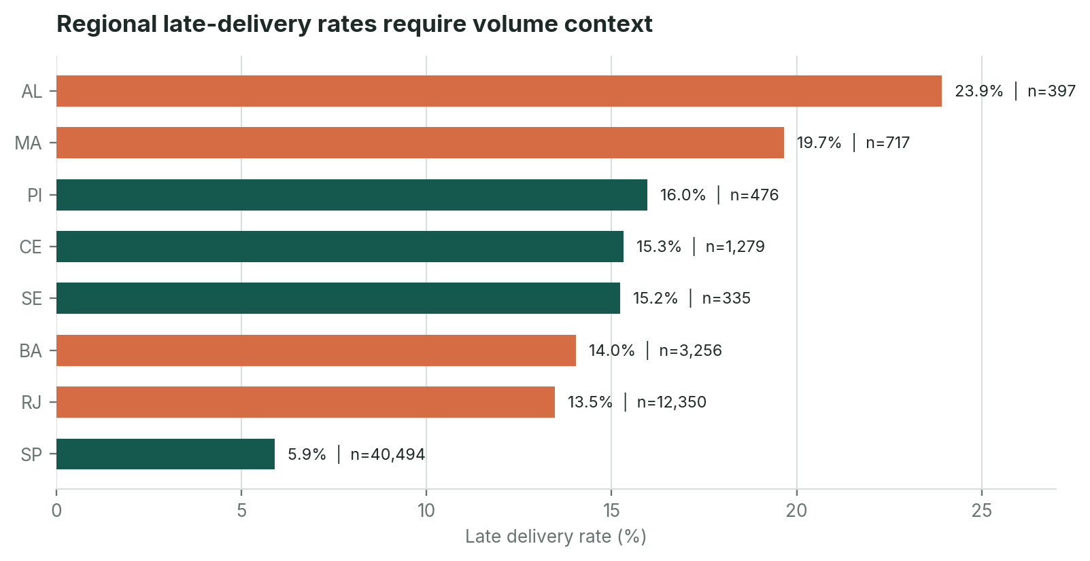
Figure 3. Selected high-rate states (minimum 100 eligible orders), plus higher-volume comparators. Orange bars identify states prioritised for investigation.
Alagoas (AL) has the highest observed rate in the minimum-100-order set at 23.93%, but with 397 eligible orders. Maranhão (MA) is 19.67% across 717 orders. For scale-aware investigation, Rio de Janeiro (RJ) combines a 13.47% rate with 12,350 eligible orders (1,664 late orders), while Bahia (BA) is 14.04% across 3,256 orders. São Paulo (SP), the largest destination cohort at 40,494 orders, has a 5.89% rate. This points to a regional diagnostic priority, not a proven route or carrier cause.
Regional prioritisation
Investigate RJ and BA first because their order volumes make the elevated rates more operationally material; examine AL and MA as high-rate cohorts with smaller samples.

7. Key Findings: Freight Economics and Seller Concentration

Finding 4 — Freight differs by category
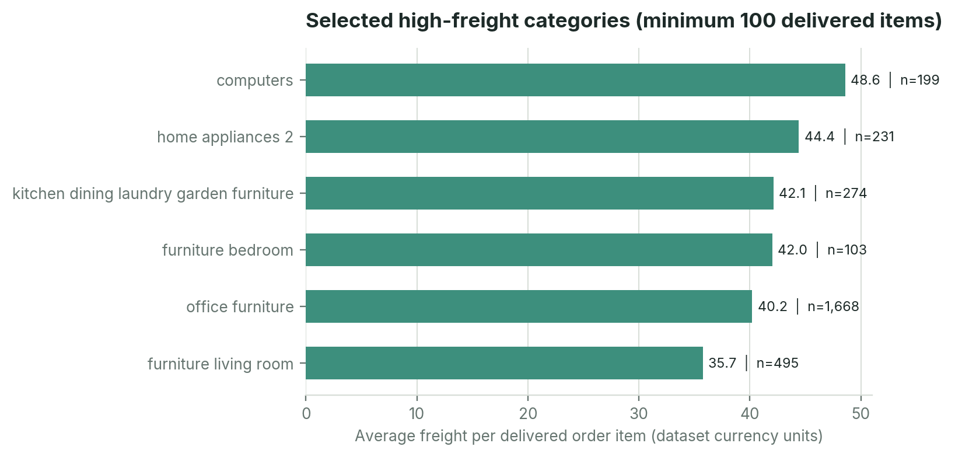
Figure 4. Highest average freight categories among delivered items with at least 100 items; item-grain metric.
Among delivered items, computers averaged 48.57 freight units across 199 items; home_appliances_2 averaged 44.39 across 231 items; office_furniture averaged 40.20 across 1,668 items. The high average for a lower-volume category should not be ranked ahead of large-volume categories without considering exposure. The dashboard’s full-population freight metrics are 2.252M total freight, 19.99 average freight per item and 16.57% freight-to-item-sales ratio (all order items).

Finding 5 — Seller item volume is concentrated in São Paulo
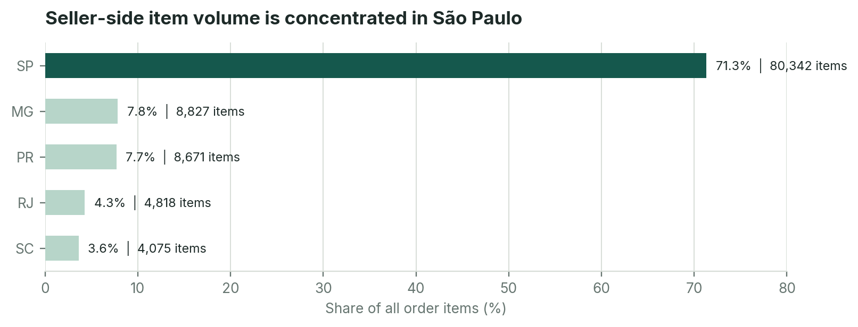
Figure 5. Seller-state share of the 112,650 order items; source: order_items_clean joined to sellers_clean.
São Paulo sellers account for 80,342 order items, or 71.32% of all order items, across 1,849 sellers. This concentration provides a useful starting point for a seller-region and destination-region diagnostic, but it does not establish that seller location caused delivery delays.

8. Root-Cause Assessment and Technical Review
The evidence supports performance segmentation and prioritisation. It does not contain the process-level variables required to isolate operational root causes.
Evidence class | What can be said
Confirmed from supplied data | 8.11% late delivery rate; 7,826 late orders; lower order-level review average for late cohort; state-level rate variation; category freight differences; seller-item concentration in SP.
Plausible explanations to test | Route distance / network coverage; carrier transit performance; seller dispatch timing; packaging or handling needs for heavier items; estimated-date promise accuracy.
Evidence not supplied | Carrier identifier and service level; warehouse pick/pack timestamps; carrier handover / first scan timestamps; route distance and transfer events; delivery attempt / exception codes; stock availability; promised-ETA history.

Python notebook review
- The 95-cell notebook defines loading, profiling, duplicate/key checks, timestamp conversion, feature engineering, order-level pre-aggregation, EDA, export and Power BI modelling guidance.
- The notebook’s KPI and EDA logic is consistent with the reproduced analysis: it derives delivery_days from purchase-to-actual delivery and delay_days from actual-to-estimated delivery.
- No cell outputs were saved in the submitted notebook, and its input path points to a Kaggle raw-data directory not included in the upload. Therefore the notebook was reviewed, but not executed end-to-end. The cleaned CSVs were analysed independently instead.

SQL review and execution
- The SQL script creates a one-row-per-order view by pre-aggregating order items, payments and reviews, preventing raw one-to-many joins from multiplying order records.
- It creates a separate one-row-per-order-item view for category and seller analysis; its comments correctly identify item-grain late rates as item-based rather than unique-order rates.
- The script executed successfully in SQLite after importing all nine cleaned tables. Its overall KPI result was 96,470 eligible, 7,826 late, 8.11% late, 12.56 average delivery days, -11.18 average delay days, 4.16 order-level mean review score and 22.79 average freight per eligible delivered order.

Power BI review
The four supplied screenshots cover an executive overview, delivery performance, product/freight/seller performance and data quality/model overview. The first three pages broadly align to independently recalculated metrics once grain is made explicit. The data-quality page has repeated row-count and null-count bars that are not valid per-table comparisons; the executive overview’s “Total Orders 113K” card should be corrected to 99,441 orders (or relabelled to 112,650 order items).

9. Business Recommendations and Prioritised Roadmap
Priority / issue | Evidence | Recommended action | Monitor | Validation needed
P1 — Standardise the delivery KPI pack | The 8.11% rate is reproducible and 7,826 late orders are visible. | Publish weekly eligible count, late count/rate, average/median delivery days, delay days, and review score by delivery cohort. | Late rate; eligible order coverage; review coverage. | Confirm consistent calendar cut-off, denominator and status filters.
P1 — Run a regional carrier / route diagnostic | RJ: 13.47% across 12,350 orders; BA: 14.04% across 3,256; AL/MA have high rates but lower volume. | Segment by carrier, seller state, origin-destination pair, distance, dispatch-to-handover time and promised lead time. | Late rate and late-order count by route / carrier / destination. | Carrier IDs, route distance, dispatch and handover timestamps are needed.
P2 — Review freight-heavy categories | Computers, home appliances and office furniture have high per-item freight in the delivered item sample. | Compare freight with product weight/dimensions, item price, package size, delivery region and actual carrier tariff. | Average freight/item; freight-to-item-sales ratio; category item volume. | Investigate dimensional weight, packaging and freight recovery; no margin impact is currently proven.
P2 — Assess seller network concentration | SP sellers account for 71.32% of order-item volume. | Map seller origin to customer destination and compare transit / late outcomes for high-volume lanes. | Seller-state item share; late rate by seller / route; delivery days. | Avoid inferring seller performance from seller state alone.
P3 — Develop a late-risk model only after instrumentation | Historical state, category, freight and dimension features could support later risk scoring. | First capture operational signals; then establish a time-based train/test split and compare model lift to a simple baseline. | Recall / precision at alert capacity; calibration; intervention success. | Prevent leakage from post-delivery fields; model output is not a substitute for carrier process data.

Implementation roadmap
Horizon | Proposed work | Suggested accountable function
0–30 days | Lock KPI definitions; correct “Total Orders” card; repair per-table row-count and missing-value visuals; publish weekly baseline. | BI / Data Analytics + Fulfilment Operations
31–60 days | Analyse RJ and BA routes alongside SP high-volume lanes; add carrier, seller, dispatch and handover segmentation. | Logistics / Carrier Management + Operations Analytics
61–90 days | Complete freight/category and seller-origin diagnostics; define event-data requirements and an intervention pilot. | Category / Commercial + Logistics + Data
After instrumentation | Build and validate a late-risk score using only features available before the intervention point. | Data Science / BI + Operations

Impact discipline
The dataset supports prioritisation and monitoring; it does not quantify guaranteed savings, ROI, delivery improvements or incremental revenue. Any benefit estimate should be measured through a controlled pilot against a documented baseline.

10. Success Metrics, Limitations and Conclusion

Monitoring plan
Metric | Definition / guardrail | Review cadence
Late delivery rate | Late eligible delivered orders / eligible delivered orders; publish numerator and denominator. | Weekly
Eligible delivery coverage | Eligible delivered orders / all delivered orders; disclose excluded delivered records. | Weekly
Delivery days | Average and median purchase-to-delivery duration; separate by region and route. | Weekly / monthly
Delay days | Average and distribution of actual minus estimated delivery; split late from on-time/early cohorts. | Weekly
Review score by delivery outcome | Order-level mean review score; show counts and review coverage. | Monthly
Freight per item and freight / item sales | State item-grain definitions; compare by category, weight band and lane. | Monthly
Seller concentration | Order-item share by seller state and seller; avoid mistaking item volume for unique orders. | Monthly

Limitations and assumptions
- Historical public marketplace data only; it does not provide live tracking or a forward-looking forecast.
- Carrier-level performance, warehouse processing timestamps, dispatch/first scan, inventory availability and delivery exception events are not available in the supplied tables.
- Late delivery is measurable only for delivered orders with valid purchase, actual and estimated delivery timestamps. Other statuses are retained but excluded from the late-rate denominator.
- Freight amounts are labelled in dataset currency units. No currency symbol is added because the supplied project notes require confirmation of the currency convention before external financial comparison.
- ZIP-prefix geolocation is approximate and does not represent exact address coordinates or actual route distance.
- Review scores are observational. Review coverage is high but not universal; blank comment text does not imply a missing score.
- Rates by state and category should be interpreted with the supporting order/item counts; low-volume cohorts can be volatile.

Conclusion
The Olist dataset shows a generally strong on-time/early delivery mix (91.89%) alongside a specific late-delivery cohort of 7,826 orders (8.11%). That cohort records a much lower order-level average review score (2.57 versus 4.29). Regional differences, freight-heavy categories and seller concentration give management clear areas to investigate, but the current evidence is descriptive rather than causal.
Decision requested
Adopt the validated KPI definitions, correct the two misleading dashboard visuals/cards, and sponsor a focused regional plus carrier/dispatch diagnostic before committing to process changes or quantified benefits.

Appendix A. Evidence Register and Verification Status
Finding / asset | Source | Calculation / logic | Status
Overall delivery KPIs | orders_clean(2).csv; v_order_level_analysis; SQL Section 5 | Recomputed timestamp differences; delay_days > 0; order-level count. | Verified; Python and SQL agree.
Review-score comparison | reviews_clean(2).csv; orders_clean(2).csv; SQL Section 6 | Average review records per order, then cohort mean; score count shown. | Verified; order grain.
Customer-state performance | customers_clean(2).csv; orders_clean(2).csv; SQL Section 7 | Eligible delivered orders grouped by customer_state; count and rate. | Verified; rate comparisons include n.
Category freight | order_items_clean(2).csv; products_clean(2).csv; category_translation_clean(2).csv; SQL Section 8 | Delivered items grouped by translated product category; average freight per item. | Verified; item grain; minimum 100 items when ranking.
Seller concentration | order_items_clean(2).csv; sellers_clean(2).csv; SQL Section 9 | Order items grouped by seller_state; share = state item count / all item rows. | Verified; item grain.
Source-table integrity | All nine cleaned CSVs; SQL Sections 1–3 | Row counts, nulls, duplicate keys and relationship orphan tests. | Verified for stated checks.
Python notebook | Olist_Ecommerce_Complete_Analysis_Easy_to_Intermediate(3).ipynb | 95 source cells reviewed; no saved execution outputs. | Code reviewed; not run end-to-end.
Power BI screens | Four supplied PNG captures: executive, delivery, freight/seller, data quality. | Visual extraction and cross-check against clean CSVs. | Screenshot evidence; underlying PBIX/DAX not supplied.
Business scope and KPI definitions | Olist_Ecommerce_Business_Problem(2).pdf | Problem statement, analytical scope, KPI definitions and limitations. | Source-derived framing.
Project narrative | executive_summary(1).md; methodology(1).md; business_recommendations(1).md | Used for intent and recommendations; conflicting older metrics reconciled against CSVs. | Narrative reviewed; stale figures disclosed.

Key reproducibility notes
- SQLite execution: all statements in the supplied SQL script compiled/executed after the nine source tables were imported; the KPI view was queried independently and agrees with the cleaned CSV recomputation for late count, eligible count, rate, delivery days, delay days and freight per delivered order.
- Notebook execution: not claimed. The source notebook still references a Kaggle input folder and has no stored outputs; this report reproduces core calculations directly from the uploaded cleaned tables.
- Dashboard validation: no PBIX or DAX definitions were uploaded. Screenshot metrics are treated as visual evidence and cross-checked only where the cleaned tables and documented KPI definitions allow.
Source files reviewed: Olist_Ecommerce_Business_Problem(2).pdf; Olist_Ecommerce_SQL_Analysis_Beginner_Intermediate(2).sql; Olist_Ecommerce_Complete_Analysis_Easy_to_Intermediate(3).ipynb; executive_summary(1).md; methodology(1).md; business_recommendations(1).md; and nine supplied cleaned CSVs.

Appendix B. Supplied Power BI Dashboard Evidence
These are the four dashboard screenshots supplied with the project. They are reproduced as evidence snapshots, not used as design references for the new presentation. Figures were cross-checked against the underlying cleaned CSVs where possible.

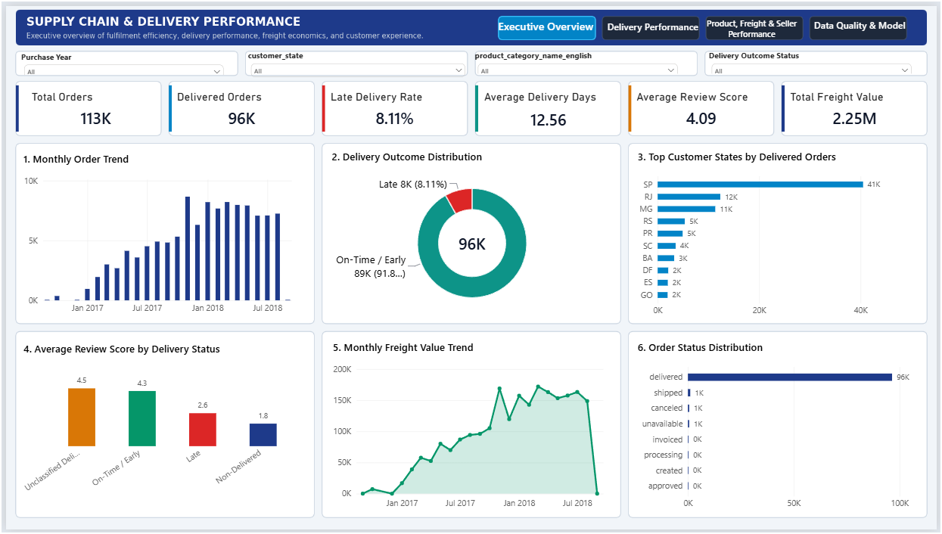
Figure B1. Executive overview screenshot. The “Total Orders 113K” KPI corresponds to order-item row count; correct unique order count is 99,441.

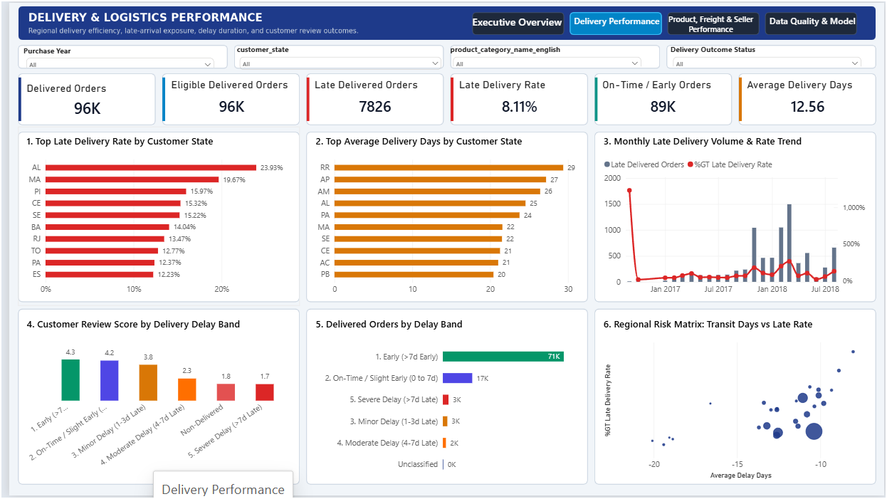
Figure B2. Delivery performance page. 7,826 late orders and 8.11% rate reconcile to the eligible delivered denominator of 96,470.

Appendix B. Supplied Power BI Dashboard Evidence (continued)

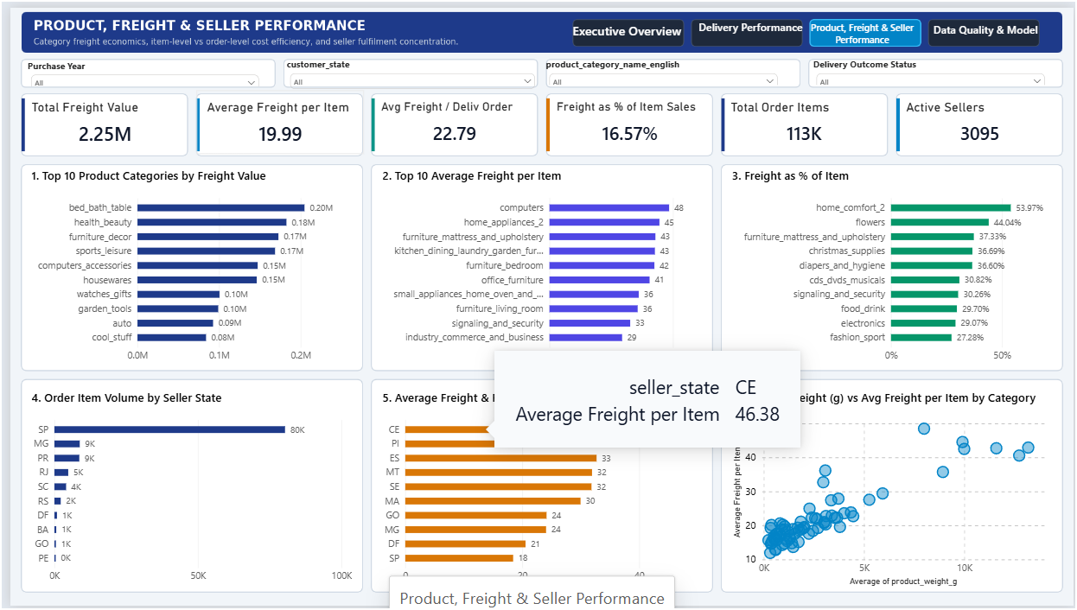
Figure B3. Product, freight and seller performance. Total freight 2.252M and average freight per item 19.99 reconcile at all-order-item grain.

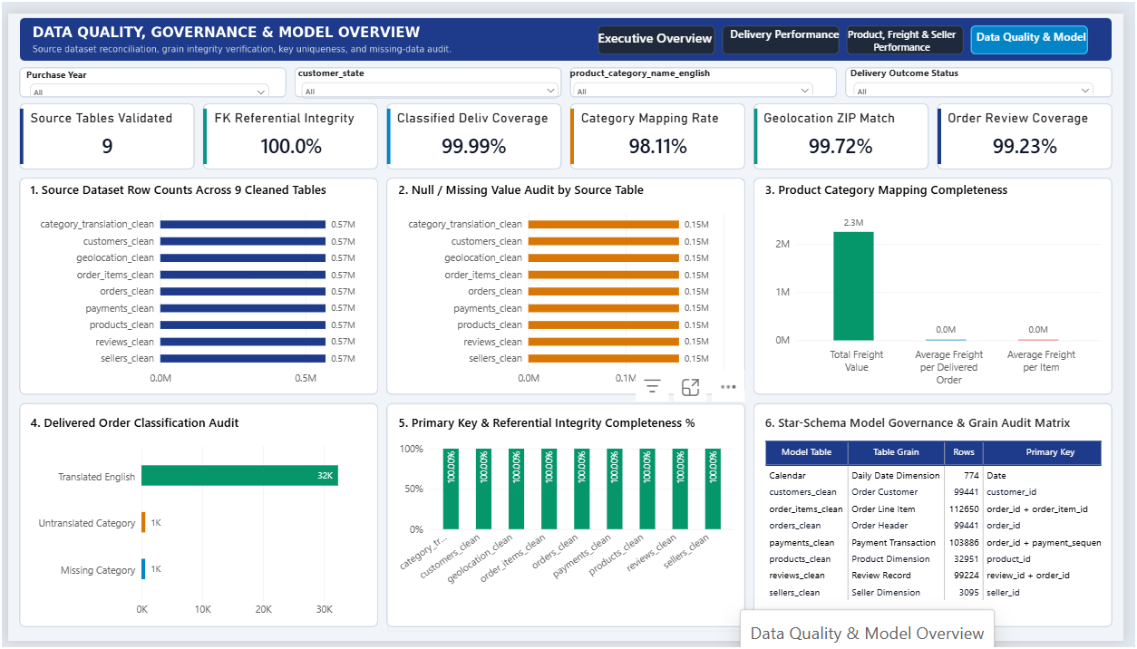
Figure B4. Data quality and model overview. The repeated 0.57M row bars and 0.15M missing bars are not valid per-table values; see Section 3.

